Grove - Infrared Reflective Sensor
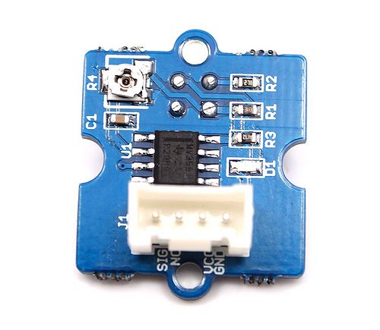
Grove - Infrared Reflective Sensor is used to detect the presence of an object within a specific range. The sensor consists of an IR LED and a photosensor (phototransistor) pair. The light emitted by the IR LED gets reflected by any object placed in front of the sensor and this reflection is detected by the photosensor(phototransistor). Any white (or lighter) colored surface reflects more than black (or darker) colored surface.
When the reflected light is detected, it produces Digital HIGH (or Binary 1) output on the SIG pin. The on-board LED indicator will also glow. If no reflection is detected or if the object is too far from the sensor, the output on the SIG pin stays at Digital LOW (Binary 0). The on-board LED indicator will be off as well. The detectable range of this sensor is 4–16 mm. The module incorporates a Rail-to-Rail Operational Amplifier to amplify the output of phototransistor. There is a potentiometer which can be used to adjust the gain of the amplifier, that is, sensitivity of detection.
With this sensor, you can build the following (but not limited to) applications: line following robots, optical encoders and object counting applications.
Note: This product is also mildly sensitive to non-IR radiations and hence any bright light on photosensor impairs or disturbs IR light detection.

Version Tracker
Product version | Release date | Support status | Notes
Versions older than v1.2 | June 2012‎ | Not supported | None
Version 1.2(current version) | April 2016 | Supported | None

Specifications
Operating voltage(V) | 4.5–5.5V
Operating current(mA) | 14.69–15.35 mA
Effective detectable distance | 0.5–4.5 cm
Response time | 10 μs
Phototransistor: Peak sensitivity wavelength | 800 nm
IR LED: Peak light emitting wavelength | 940 nm
Reflective photosensor | datasheet
Output operational amplifiers | datasheet
Weight | 4 g

Hardware Overview
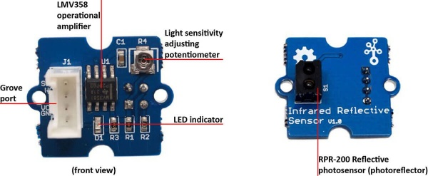
- RPR220 Reflective photosensor, Highly sensitive reflective photosensor.
- LMV358, rail-to-rail operational amplifier.
- LED Indicator, The LED will switch on when the received infrared light intensity exceeds a preset level.
- Light sensitivity adjustment potentiometer , adjust the sensitivity of photosensor to light.

